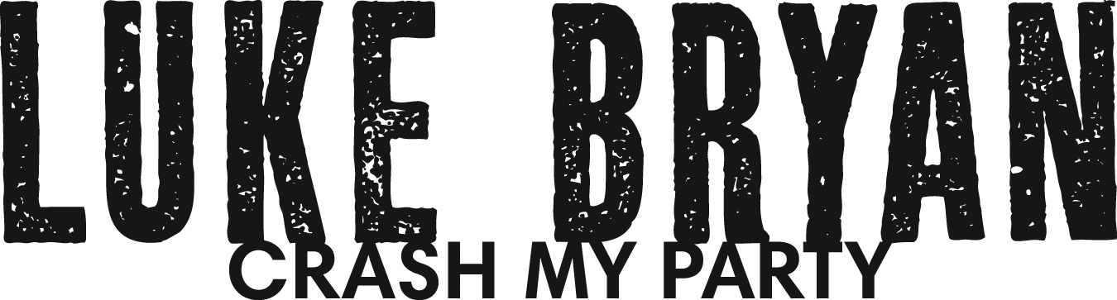

Superstar and Stadium Headliner Luke Bryan is at the top of his game and yet, his latest album, Crash My Party, proves he has no limits.

Crash My Party is the follow-up to Luke’s most successful album to date, tailgates & tanlines, both have been certified Double Platinum. The latter album featured three back-to-back Platinum and Double Platinum singles and has sold over 10 million tracks while Crash My Party currently feature four consecutive No. 1 singles and sold nearly 7 million tracks.
Crash My Party debuted at #1 on the Billboard 200 and Country sales chart, selling 527,783 copies, making it the largest sales debut at the time for a Country male artist since 2004. Additionally, Luke is one of only two country artists – the other being Taylor Swift – that have sold more than a half-million copies of an album in a single week since 2008. This is Bryan’s second consecutive Top 200 #1 album and since its release has now sold over two million copies.
Crash My Party also releases on the heels of Luke’s most successful Spring Break series album, Spring Break…Here To Party, which debuted at No. 1 on Billboard’s Top 200 chart and is certified Gold.
Luke’s superstar status was further cemented by the 2013 Academy of Country Music Award win for the highly coveted fan-voted Entertainer of the Year, in addition to his win for Vocal Event (“Only Way I Know” with Eric Church and Jason Aldean), along with his first-time ACM hosting duty with Blake Shelton. That same year, he also won a Billboard Music Award as Top Country Artist and was honored as the Favorite Male Artist- Country at the American Music Awards. In December of 2013, Luke was named Artist of The Year at the American Country Awards, the night’s highest award, as well as Artist of the Year, Male and Touring Artist of the Year bringing his total career wins at the ACA’s to 12!

In 2014, Luke co-hosted the ACM Awards for a second time and won two additional Billboard Music Awards, including Top Country album for Crash My Party as well as two CMT Music Awards. And the amazing news is that the Leesburg, Ga., native has only scratched the surface of what he can achieve.

Bryan’s latest album, by far his best yet, builds on the success of his previous releases and proves that his rich musical mine has only begun to be tapped.

First single and title cut “Crash My Party,” a multi-week No. 1, Double Platinum single, is full of playful longing. “It’s a great hook and a great way to say, ‘come love on me,’” says Luke. The album also contains three additional No. 1 singles, “That’s My Kind of Night,” “Drink A Beer,” and “Play It Again” bringing his career No. 1 total to ten. Luke’s current single “Roller Coaster” is the fifth release from Crash My Party.

“I decided Crash My Party was perfect title for this album because, like the song, the album goes beyond the literal meaning of the title,” Luke explains. “The song isn't what you think it is, it is unexpected, and in the same way fans will definitely hear some surprises on my new album. It still reflects my sound but you will get to hear a little bit deeper, different side to me musically as well.”

A different side indeed. Luke’s career album—once again produced by Jeff Stevens—includes, “Goodbye Girl,” which taps into a new vein for Bryan. “Usually I’m singing kind of loud and forceful and on ‘Goodbye Girl’ I’m using my tender, Conway Twitty-like, soft voice,” Luke says. “It’s one my favorite things I’ve ever recorded.”

Back road party song “Beer In The Headlights” may tread on familiar territory but the song finds Luke stretching vocally. “This album has some songs that showcase a big voice and long notes and we’ve never done that before,” Luke says, referencing “Beer In The Headlights,” the inspiring “Blood Brothers” and the head-over-heels love song “Roller Coaster.”

Luke calls the sticks-in-your-head “Play It Again” “one of the biggest hits on the album. How many times have you or your girlfriend had a favorite song and when it comes on it fires you up?” Luke says.

“Dirt Road Diary,” which Luke co-wrote with fellow Georgians Dallas Davidson, Rhett Akins and Ben Hayslip, is the story of his life, he says. “It wrote itself. Dirt roads were an important part of my childhood.”

“’Dirt Road Diary’ is a song that I can envision country boys driving around on a dirt road listening to,” Luke adds.

Luke’s first headline tour in 2013, the “Dirt Road Diaries Tour,” played for 1.3 million fans with all dates selling out! His new tour, “That’s My Kind of Night Tour,” launched in January 2014 and sold-out all dates on the tour’s first leg, including two sold-out Madison Square Garden shows. As the tour continues this summer Luke will play his first stadium dates in Pittsburgh, Boston, Philadelphia and Chicago.

His annual Farm Tour, which is held in every fall and is a way to give back to local farming communities, continues to connect the son of a peanut farmer with his rural roots. It’s not surprising then that rural themes are a staple for Luke’s music. “’Shut It Down’ is a song that touches on rural areas and farming and I feel like I always have to have those songs,” Luke says emphatically.

As with his new album, Luke is determined to give the fans on his headlining tour the most for their hard-earned money. “My main thing is to keep upping the ante and upping the sound and staying creative,” Luke says adamantly. “I don’t want to give the fans the same thing year in and year out. I want to give them something they’ll come back to for years and years to come.”

“I aspire to do it for many years at a high level and keep growing it,” he emphasizes. “It’s amazing looking out there and knowing that the people in the audience are your crowd. They came to see you. It’s what I dreamed of when I moved to town.”

Luke had a number of dreams when he moved to Nashville but even he has to be surprised by his success, including multi-Platinum albums sales, back-to-back No. 1 singles and his first No. 1 album debut. His Spring Break shows in Panama City Beach, Fla., in March of 2014 brought in 230,000 fans during the two-day concert event.
For all he has achieved—and it’s plenty—Luke remains steadfast in what’s important to him: family. “I can’t be more happy in life than when I’ve got my family with me and I get to go out and do shows for a living,” says Luke. “The only negative about this is business is being away from your family, so when they’re out on the road with me, the negatives are removed and it’s nothing but positives.”
Luke calls his 2013 ACM Entertainer of the Year award “validation. It’s checking the biggest goal for your career off the list. It reminds me just how wonderful my fans are. It’s every emotion possible.”

As important as the award is, Luke says his life is filled with pinch-me moments. “Every night that I’m selling places out is a pinch me moment,” he says humbly. “When a fan comes up to me in the Boston airport because she recognized me is a pinch me moment. I tend to have a lot of pinch me moments. There’s a lot of amazing stuff coming my way and I try to remember it and appreciate it.”

With the imminent success of Crash My Party, it’s certain Luke will have plenty more pinch me moments to remember and appreciate.

